Supplementary materials

Characterization, Identification and Expression Profiling of Genome-Wide R-Genes in Melon and Their Putative Roles in Bacterial Fruit Blotch Resistance

Md. Rafiqul Islam^{1,2}, Mohammad Rashed Hossain^{1,3} , Denison Michael Immanuel Jesse¹, Hee-Jeong Jung¹, Hoy-Taek Kim^{1,*}, Jong-In Park¹ and Ill-Sup Nou^{1,*}

¹Department of Horticulture, Sunchon National University, Suncheon, Jeonnam, 57922, Republic of Korea
²Department of Biotechnology, Sher-e-Bangla Agricultural University, Dhaka 1207, Bangladesh
³Department of Genetics and Plant Breeding, Bangladesh Agricultural University, Mymensingh-2202, Bangladesh

Authors’ email addresses:
rafiqul@sau.edu.bd (MRI); m.r.hossain@bau.edu.bd; (MRH); michaelijesse@gmail.com (DMIJ); gml79wjd@sunchon.ac.kr (HJJ); htkim@scnu.ac.kr (HTK); jipark@sunchon.ac.kr (JIP.) and nis@scnu.ac.kr (ISN).

*Correspondence: htkim@sunchon.ac.kr (HT K); nis@sunchon.ac.kr (ISN), Tel.: +82-61-750-3249 (ISN); Fax: +82-61-750-5389 (ISN)

Table S1. Specifications of the primers designed for expression profiling of melon R-genes.
Sl. | Gene ID | Primer | Forward (5’-3’) | Reverse (5’-3’) | Product size (bp)
1 | MELO3C023580.2 | M3580 | CGGAGAAGCAGCAGTCCAAG | TTTGGCCAAAACCTGCCTTC | 131
2 | MELO3C023579.2 | M3579 | GAGGCTCTCCGTCGAGAAGT | GGGAAATAACATCTAGCCTC | 145
3 | MELO3C023578.2 | M3578 | GAGTGTGAGGGAGGTACGAG | CTGTCTTTCCTAATCCTCCC | 194
4 | MELO3C023577.2 | M3577 | GCAAAGTTGAAAGGTTCTCC | TCTTGTTGTAAAGTTGTGCC | 125
5 | MELO3C023441.2 | M3441 | GGGAAAGAGTTAAATGCGAC | CCATCTAGACCTTGGTTTCC | 205
6 | MELO3C023440.2 | M3440 | CCCCCTACACGACATCATGT | TGAATCTGTACCAAGTCTCC | 196
7 | MELO3C023439.2 | M3439 | GGCTCTATCACTTTACTTGG | AACTTAGATCCAACACCCTC | 118
8 | MELO3C023438.2 | M3438 | GCGGAAACATTGAGGATGCA | CGGTTTCTCGACATTTGGAC | 139
9 | MELO3C023437.2 | M3437 | CCAACTAACAGGTGATATTC | AGTGTACCAAGTTCAGGAGG | 183
10 | MELO3C029319.2 | M9319 | TGGTCCCGTAGAACGCACA | TGATGTGTGCACCCTTCGGG | 144
11 | MELO3C015353.2 | M5353 | GGGGAGAAATCAAGGAGTTC | AATTGACACAAGTCGAGTCC | 131
12 | MELO3C015354.2 | M5354 | CCGGTTTCCATGAGGAGC | CATAGGAGAACTCATCCATC | 171
13 | MELO3C029505.2 | M9505 | GGCAGGATCGAGCGAGCTTT | CTGCTCTTGCTTCAAATCGG | 177
14 | MELO3C010346.2 | M0346 | GCGCAGCAACCGTCCATTGA | CCCGCCATTCACAACAAAGC | 193
15 | MELO3C010827.2 | M0827 | CGGTACAATTCCCCCATCTT | GGTAGAGGGAACAATGCCAC | 163
16 | MELO3C010826.2 | M0826 | GGCCCCATTCCCTCCCAATT | CCCCAAAGGTTGTTGGAGGC | 146
17 | MELO3C010825.2 | M0825 | GGACCAATTCCAACCGAGCT | GAAGTGTATCACCAATATCC | 178
18 | MELO3C009695.2 | M9695 | CGTGCTCTAGTCGAATTTCT | TCTCCATACTTATGGAACCG | 141
19 | MELO3C009694.2 | M9694 | CGTGCCCCACAGTTCAAGTT | TACCAGGCTTTCCCATCCTC | 132
20 | MELO3C009693.2 | M9693 | GCGACGATTTGGATGAAATT | CATTAGTCAACGGGTAAAGC | 144
21 | MELO3C009179.2 | M9179 | GGAAGTGGGAATGTCGATGA | CCAAGGTTAATATTGTCAGC | 151
22 | MELO3C009177.2 | M9177 | CGACCCACTCAAAATCATGA | CGTAGAATCTGTTGTCTCCC | 197
23 | MELO3C004259.2 | M4259 | GGGTTCGAGGGTGTTAACAT | GCCCATGCTTTGAAGCTTCT | 151
24 | MELO3C004288.2 | M4288 | GGAATTGGAGGTATGGGCAA | AATCTCACGAAGTAGCTCCC | 156
25 | MELO3C004289.2 | M4289 | CGTGGTGTTTGGATGAATTG | AGTAGTTAAAGCATCCCTCC | 191
26 | MELO3C004301.2 | M4301 | GCGGTTTTGCCGGTGTTCTA | CAACCAGACAAACCAGCAGC | 161
27 | MELO3C004303.2 | M4303 | GGTTGGTGGACGTGATTGGT | ACTTTCCTTAAAAGCATGCC | 163
28 | MELO3C004309.2 | M4309 | GGGCCAGCTTGTTTTGCCAA | TCAGCCTCCTTCCTAGTTCC | 189
29 | MELO3C004311.2 | M4311 | GGATGGACGGTTCTTCAAAA | CATCTGCAGACATAACGTGG | 169
30 | MELO3C004313.2 | M4313 | GGTTTGGACCTGGAAGTATG | TCACAATAACGTACGGCACG | 199
31 | MELO3C006780.2 | M6780 | GGCGAGGCTAGTGCTGTTGG | GTAATCCTTTCATGAGTGGC | 179
32 | MELO3C006801.2 | M6801 | GCCGTGTCCAGAAGGTCATT | GGAAGGGGCTCTATTGATGC | 133
33 | MELO3C016529.2 | M6529 | CCGTGTGGCGGTCGGCGGTG | ACAATGCCGCCACCGTCTTC | 152
34 | MELO3C013803.2 | M3803 | CTGGGATGGATAATGGGAGG | TCAAACACTGACTCTGGAGG | 139
35 | MELO3C017700.2 | M7700 | CCCTCTTGTTCGTCATGATA | AGTTGTTTCCCTAATCTGCC | 157
36 | MELO3C017701.2 | M7701 | GCGGCGAGTATCATGGGGCT | CTCTAATACTTCAGCTTCCC | 129
37 | MELO3C017703.2 | M7703 | GTTCTACTCGATGAGCTCGC | GTACTAGCAGCAGAATAATG | 179
38 | MELO3C007354.2 | M7354 | CTCTGCCGAGGCGATCTTAT | CTACACCAAATATGGAAGAG | 154
39 | MELO3C007358.2 | M7358 | CGTACTTTTCTCCATCTCTT | TAGTAATCCTCAGCGTGGAG | 170
40 | MELO3C007360.2 | M7360 | CCAAACCAGAAAGAAGCTGC | CAGCCGGTCAAGCAAATTCC | 171
41 | MELO3C007367.2 | M7367 | GGCCGATCTAACGGTGGAAG | ACTCGGTCGACCCAAACGCC | 159
42 | MELO3C022157.2 | M2157 | GGAATCCATGGACGACGGAA | TCCCTCCACCGATGAACCTG | 156
43 | MELO3C022154.2 | M2154 | GCTAACCTCAAAGCTTGGCT | CCTCATCAGAGTTTGGGATC | 184
44 | MELO3C022152.2 | M2152 | GGAGAGAAACCGTATGGTGT | GATCCATCAACTCCTTACAC | 145
45 | MELO3C022146.2 | M2146 | GTACGGATGAACAAAAGCAT | TCCATTGTTGAACCTCCTCC | 174
46 | MELO3C022145.2 | M2145 | GGGGTATGCTACTTCCAAGT | TTCCTGACGTCTATTAATGG | 171
47 | MELO3C022144.2 | M2144 | GGCAATCACACTGGAGTTGT | AATCGGGATGTCATTCCAAC | 140
48 | MELO3C025516.2 | M5516 | GCTGATGGAGCTACGTTAAT | CTTGTTGTAACGATGACTCG | 149
49 | MELO3C025519.2 | M5519 | GCGGCATTTCTAATGGAGGG | CAACTCCTCCCATAGAAAAC | 131
50 | MELO3C025518.2 | M5518 | GGCACACGGTTTTCTTCAAC | TTCTTCTATTCTTCTGGTCC | 136
51 | MELO3C005450.2 | M5450 | GAGAGGGATGGACTTTTCCA | AAAGCCTTAGGAATTTGACC | 135
52 | MELO3C005451.2 | M5451 | CTTCCCATCGCTTGGCTTCG | ATGAAGGTGATGAGTCGACC | 132
53 | MELO3C005452.2 | M5452 | CCCAAGCTTTTTAGGTTCAA | ATCGTCATTGGTTTCCGGCC | 148
54 | MELO3C012268.2 | M2268 | GTACTCCGCCTCCGCCGGGT | ACACCACCACCGTCATCTAC | 163
55 | MELO3C012049.2 | M2049 | CGTCCCTGTTCGCCTCCTCA | CCCACTCAACTTCAAACCCC | 190
56 | MELO3C012045.2 | M2045 | GACCAGGAAATTCGGCAAGA | CAGCAGTAGAGGAGATCTCG | 174
57 | MELO3C034399.2 | M4359 | ATGGTGCAAAATATCAAGCT | CCAACTGTATACAATATCTC | 191
58 | MELO3C022580.2 | M2580 | CAGATTCCGGAGACAACCTC | GATTGAAAACCATCTTGGCC | 175
59 | MELO3C022447.2 | M2447 | CGTGTATGCGATCCAAAAGA | TCGTCGCATTTCACGCCATC | 167
60 | MELO3C022449.2 | M2449 | GCAAGGTGAAATCTCAGAGT | GAAGAACGCTTAGACTTGGG | 128
61 | MELO3C002671.2 | M2671 | CTCCCACCGACATCGCCGTCG | GTAGGAATACAAGGTGGCGA | 172
62 | MELO3C002667.2 | M2667 | CATGGGTCTCACAGGAACCT | CCACGAAGGAATCTCTCCAC | 175
63 | MELO3C002666.2 | M2666 | CCATTCCTGTATCCATTTTC | ATCTTCCAAGTTTTCCGATC | 174
64 | MELO3C002506.2 | M2506 | CAAGCTAATTTAGACCACCT | CAGTTTTTGGGGAGAAGGGT | 182
65 | MELO3C002504.2 | M2504 | GTCCCTACAAAGCCAATCTA | GAAGGGTTATTGAGTTGGTG | 177
66 | MELO3C002501.2 | M2501 | CTCGAGGTATGTATGCGTGG | CGGCGCCGTAAGAGGAGTTG | 146
67 | MELO3C002394.2 | M2394 | CTGCTCGTCTTTCTTCTTGG | CGGTTGTTCATAACCCCCAC | 161
68 | MELO3C002393.2 | M2393 | CACTCTCACCCATGTTGGGA | TGATGAATATGTGGGAGAAG | 128
69 | MELO3C002392.2 | M2392 | CCGACGAACGAGGATTCATG | CAATTACTTAAGTGCAGCTC | 169
70 | MELO3C002389.2 | M2389 | GGAGGATTGGTCTGAGAGTA | AAAGATCAAGGTGGAGCAGG | 176

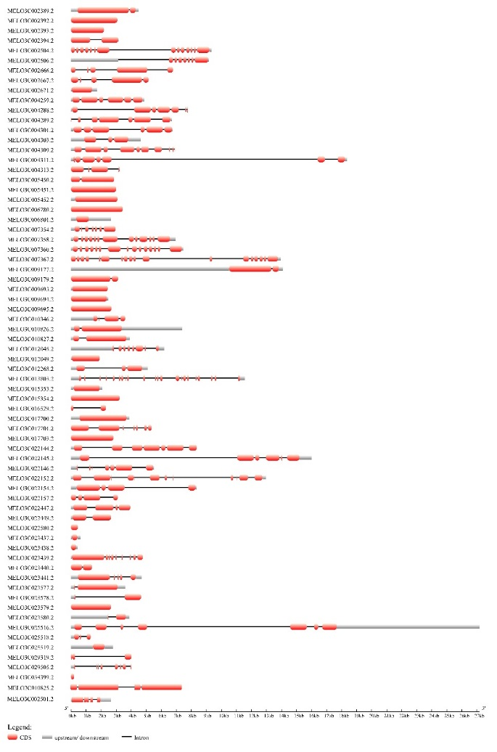

Figure S1. Exon–intron structures of R-genes in melon genome-wide. Light red rectangles and black lines indicate exons and introns, respectively.

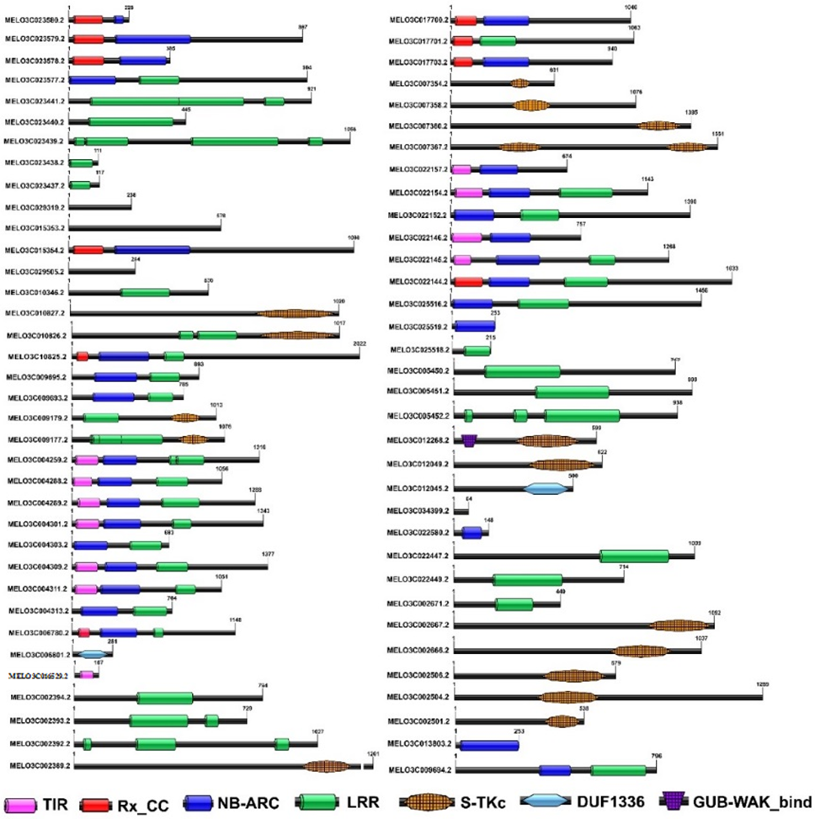
Figure S2. Domain structures of the 70 R-genes in melon. The conserved domains were identified using the NCBI Conserved Domain Database (CDD) (https://www.ncbi.nlm.nih.gov/Structure/bwrpsb/bwrpsb.cgi). Detailed descriptions of these domains are provided in Table 2. Specific domains in each protein are shown in the diagram.

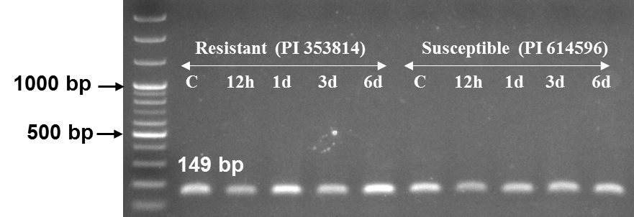

Figure S3. Gene expression profiles of resistant and susceptible melon accessions at different time points normalized to melon Actin expression (CmACT7, 149 bp), as determined by qRT-PCR analysis.

